Visualización de la información - Covid-19

Manuel Rueda

#### Abril 2021

Introducción a visualización estática

Scatterplots - Gráfico de puntos

library(dplyr)  
library(ggplot2)  
library(plotly)  
  
covid <- read.csv('covid_19_spain.csv', sep = ';', stringsAsFactors = FALSE)  
  
covid <- covid[covid$Confirmed > 0, ]

plot(covid$day, covid$Deaths)

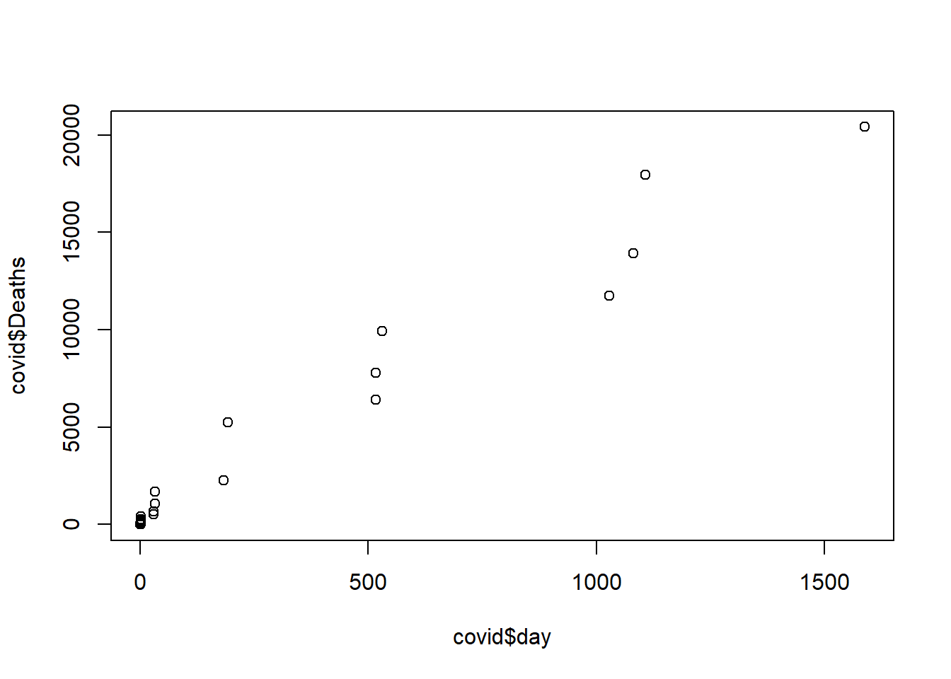

ggplot(covid, aes(x = day, y = Deaths)) +  
 geom_point()

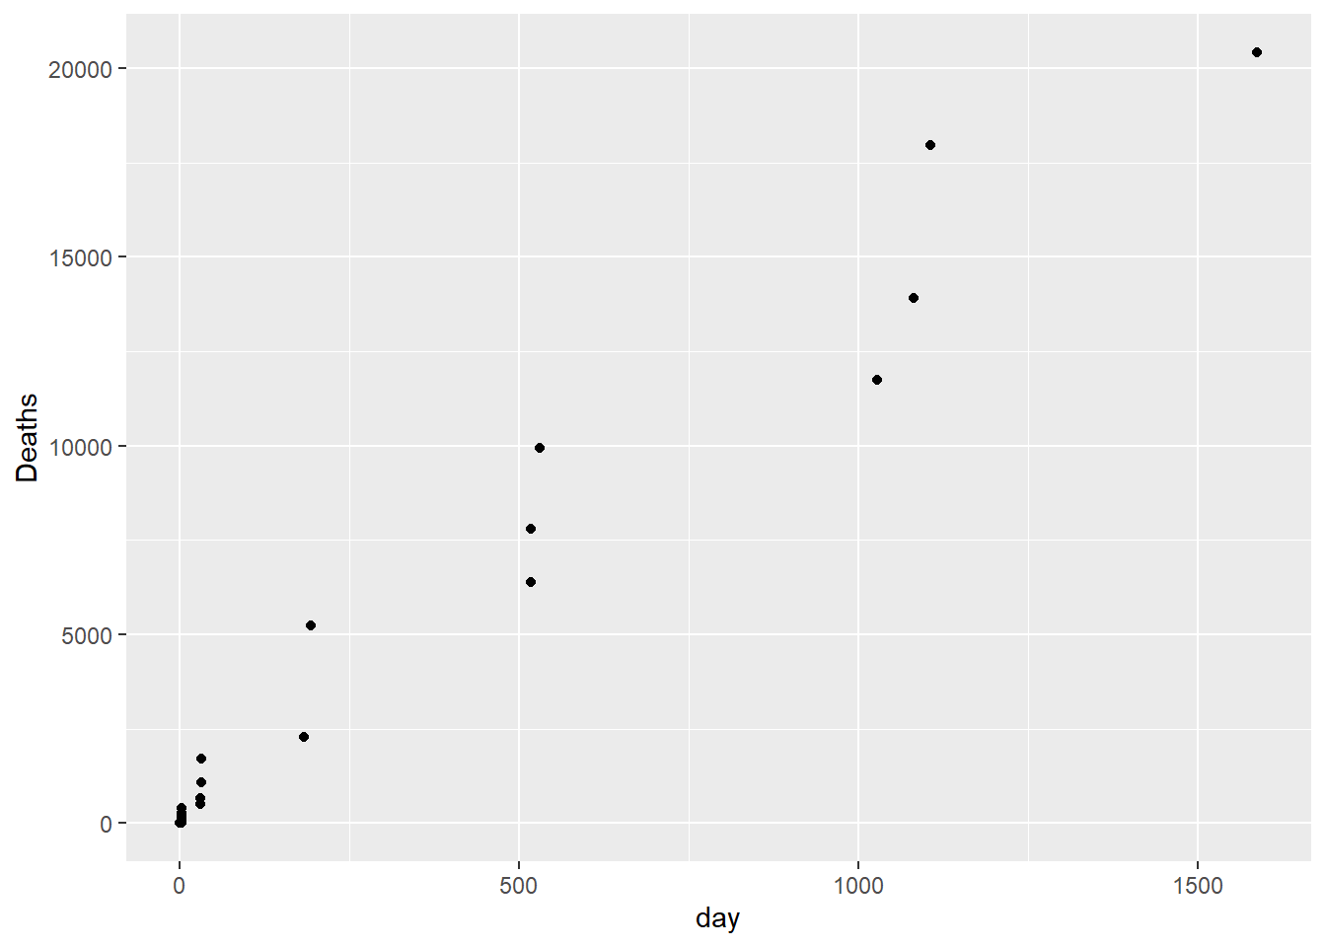

g <- ggplot(covid, aes(x = day, y = Deaths)) +  
 geom_point(colour = 'lightblue', alpha = 0.5) +   
 geom_line(colour = 'lightblue')  
  
g

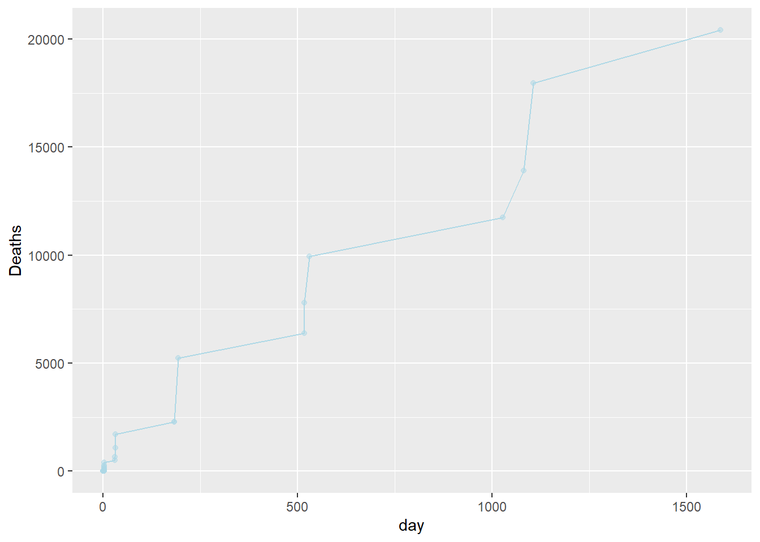

ggplotly(g)

g <- ggplot() +  
 geom_line(data = covid, aes(x = day, y = Deaths), colour = 'red', alpha = 0.7) +   
 geom_line(data = covid, aes(x = day, y = Recovered), colour = 'darkgreen', alpha = 0.7)   
  
ggplotly(g)

Bar Plot - Gráfico de barras

g <- ggplot(covid, aes(x = day, y = Confirmed)) +   
 geom_col(position = 'dodge', fill = 'lightblue', color = 'darkblue')  
  
g

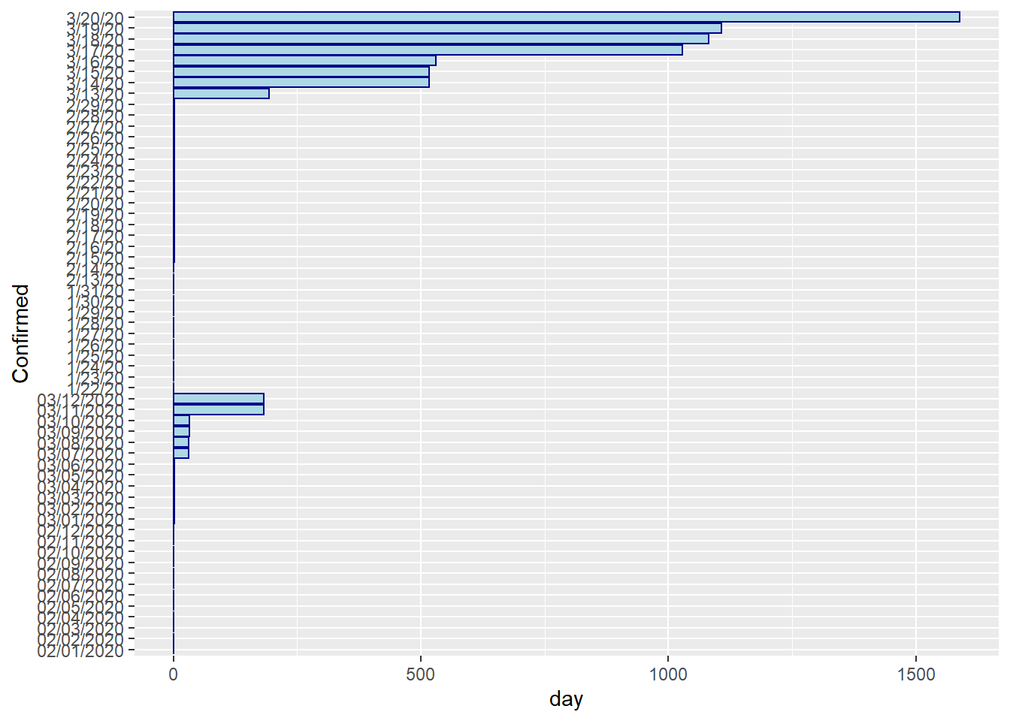

ggplotly(g)

Lines - Gráfico de líneas

Enfermos en España, China e Italia

library(lubridate)  
  
covid <- read.csv('covid_19.csv', sep = ';', stringsAsFactors = FALSE)  
  
covid$Date <- mdy(covid$Date)  
  
covid <- covid %>% filter(Country.Region %in% c('China', 'Italy', 'Spain'))  
  
covid <- covid %>% group_by(Country.Region) %>% arrange(Date) %>% mutate(day = 1:n_distinct(Date))  
  
  
g <- ggplot(covid, aes(x = day, y = Confirmed, color = Country.Region)) +   
 geom_line() +  
 ggtitle('Enfermos en España, China e Italia') +   
 xlab('Día') + ylab('Casos confirmados')  
  
  
g

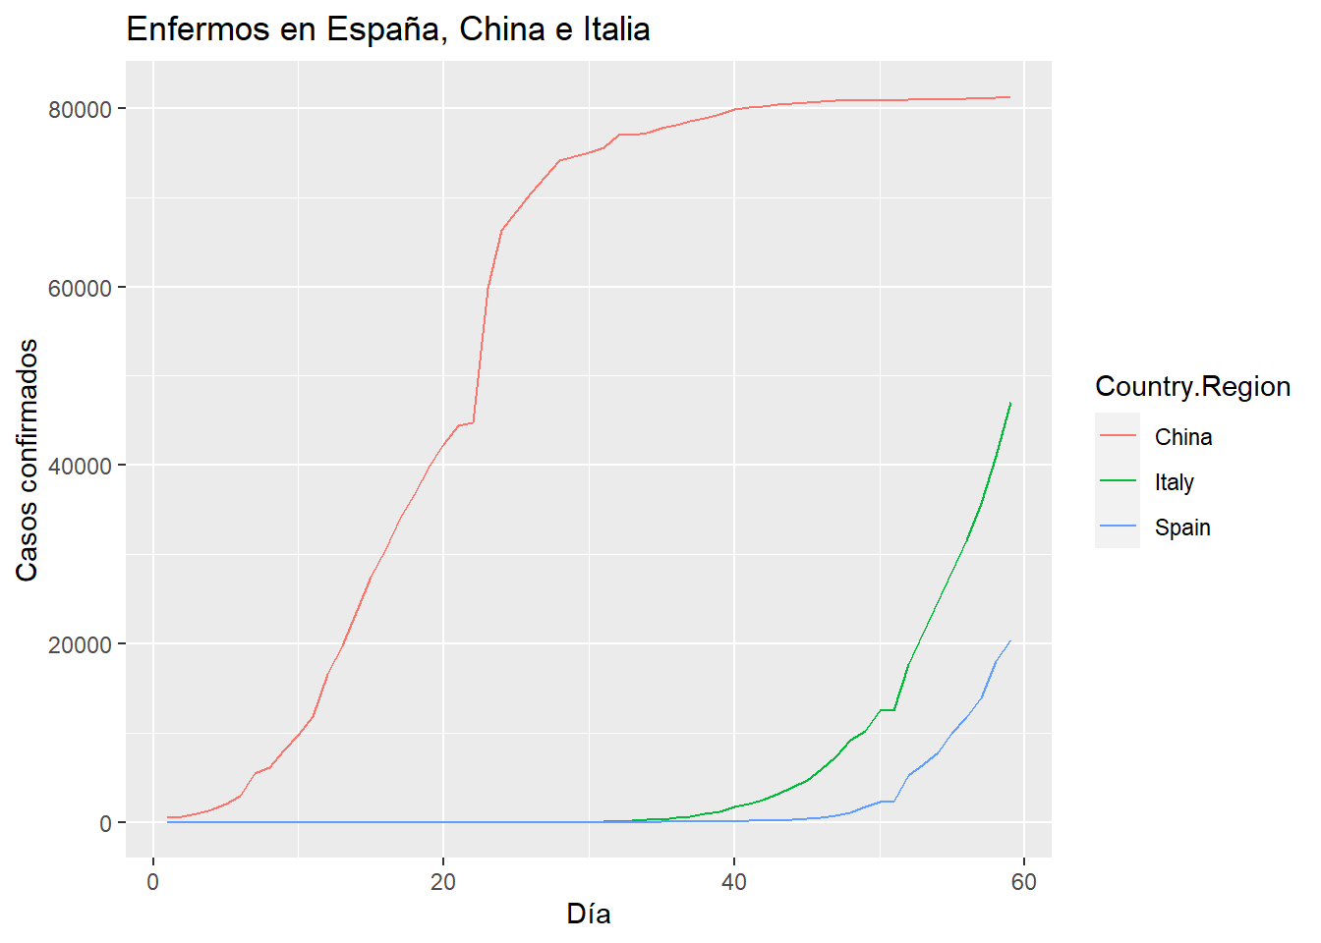

ggplotly(g)

ggplot(covid, aes(x = day, y = Confirmed, color = Country.Region)) +   
 geom_line() +   
theme(panel.background = element_blank(),  
 panel.grid.major = element_blank(),  
 panel.grid.minor = element_blank()) +  
 ggtitle('Enfermos en España, China e Italia') +   
 xlab('Día') + ylab('Casos confirmados')

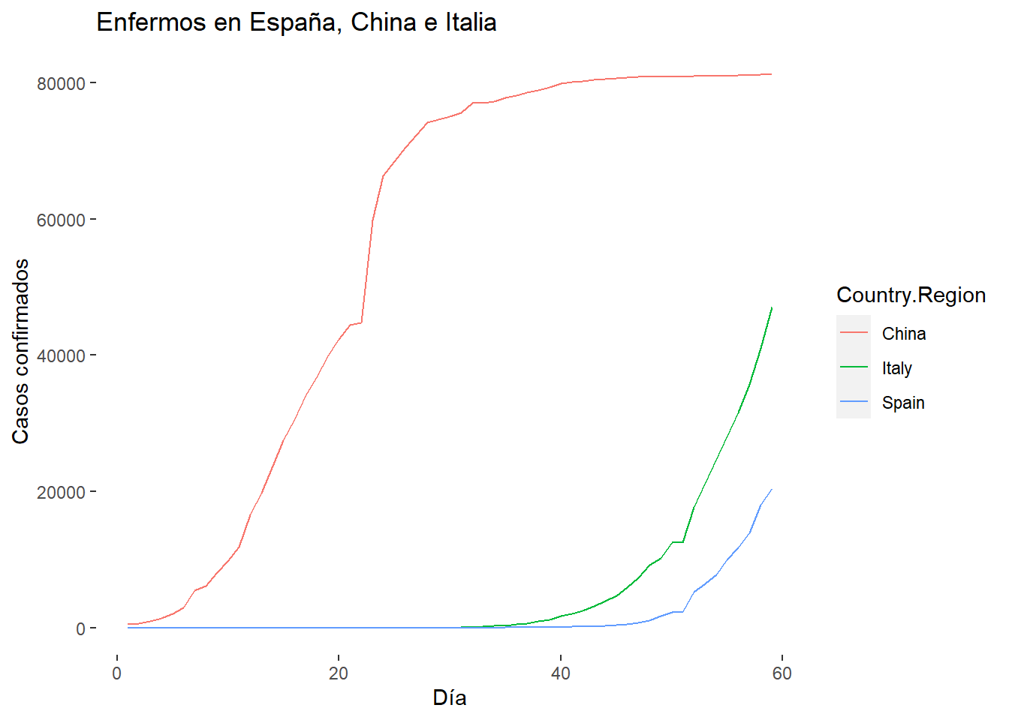

g <- ggplot(covid, aes(x = day, y = Confirmed, color = Country.Region)) +   
 geom_line() +   
theme_classic() +  
 ggtitle('Enfermos en España, China e Italia') +   
 xlab('Día') + ylab('Casos confirmados')  
  
g2 <- ggplotly(g)  
  
g2

library(htmlwidgets)  
  
saveWidget(g2, "comparativa.html")

Fallecidos en España, China e Italia

ggplot(covid, aes(x = day, y = Deaths, color = Country.Region)) +   
 geom_line() +   
theme_light() +  
 ggtitle('Número de fallecidos en España, China e Italia') +   
 xlab('Día') + ylab('Casos confirmados')

